Date of planning: …. /….. /……...
Date of teaching: …. /….. /……....

Period 69: UNIT 9: FESTIVALS AROUND THE WORLD
Lesson 1: Getting started – A Tulip Festival
I. OBJECTIVES
By the end of this lesson, Ss will be able to gain:
1. Knowledge
- An overview about the topic “Festivals around the world”
- lexical items related to the topic “Festivals”: names of different festivals around the world
2. Core competence
- Develop communication skills and cultural awareness
- Be collaborative and supportive in pair work and teamwork
- Actively join in class activities
3. Personal qualities
- Develop self-study skills
II. MATERIALS
- Grade 7 textbook, Unit 9, Getting started
- Computer connected to the internet
- Projector/ TV/ pictures and cards
- sachmem.vn
Language analysis
Form | Pronunciation | Meaning | Vietnamese equivalent
1. folk dance (n) | /ˈfəʊkˌdɑːns/ | a popular dance, considered as part of the tradition or custom of a particular people | điệu nhảy/ múa dân gian
2. costume (n) | /ˈkɒstjuːm/ | the set of clothes typical of a particular country or period of history, or suitable for a particular activity | trang phục
3. float (n) | /fləʊt/ | a large vehicle with a flat surface that is decorated and used in festivals | xe diễu hành
4. parade (n) | /pəˈreɪd/ | a large number of people walking or in vehicles, all going in the same direction, usually as part of a public celebration of something | cuộc diễu hành
5. feast (n) | /fiːst/ | a special meal with very good food or a large meal for many people | bữa tiệc
6. fireworks display (n) | /ˈfɑɪəwɜ:rks dɪˈspleɪ/ | a public event at which fireworks are set alight | màn bắn pháo hoa
Assumptions
Anticipated difficulties | Solutions
1. Students may be lack of knowledge about festivals. | - Prepare some photos/ posters of festivals.
2. Students may have underdeveloped listening, reading and co-operating skills. | - Play the recording many times if any necessary.  - Encourage students to work in pairs, in groups so that they can help each other.  - Provide feedback and help if necessary.
Board Plan
Date of teaching
Unit 9: FESTIVALS AROUND THE WORLD
Lesson 1: Getting started – A Tulip Festival
*Warm-up
Chatting and describing the picture
I. Vocabulary
1. folk dance (n)
2. costume (n)
3. float (n)
4. parade (n)
5. feast (n)
6. fireworks display (n)
II. Practice
Task 1: Listen and read.
Task 2: Read the conversation again and tick the correct column.
Task 3: Write the correct word or phrase from the box under each picture.
* Game: Who is faster?
Task 4: Fill in each blank with a word from 3.
Task 5: Quiz. What festival is it? Match each description with a festival.
* Homework
III. PROCEDURES
Stage | Stage aim | Procedure | Interaction | Time
WARM-UP | To introduce and lead in the topic | CHATTING AND DESCRIBING THE PICTURE  * Teacher shows the picture of the Tulip Festival and asks students some related questions:  - What can you see in the picture?  - Can you guess the name of the festival?  - Have you ever heard of this festival? If yes, what do you know about it?  ** Students raise hands to answer the questions.  *** Teacher and students discuss the questions.  **** Teacher accepts all students’ questions. | T-Ss  Ss  T-Ss  T-Ss | 5 mins
PRESENTATION | - To provide students with vocabulary  - To help students well-prepared for the listening and reading tasks | VOCABULARY  * Teacher introduces the vocabulary by giving definitions/ examples/ pictures of the words.  ** Teacher writes all students’ answers on the board.  *** Teacher circles or highlights the following words and discuss the meanings of these words:  1. folk dance (n) 2. costume (n)  3. float (n) 4. parade (n)  5. feast (n) 6. fireworks display (n)  **** Teacher checks students’ pronunciation and gives feedback. Teacher reveals that these words will appear in the reading text and asks students to open their textbook to discover further. | T-Ss  T-Ss  T-Ss  T-Ss | 10 mins
PRACTICE | To have students get to know the topic | TASK 1: LISTEN AND READ. (Ex 1, p. 92)  * Teacher can play the recording more than once.  ** Students listen and read.  *** Teacher invites some pairs of students to read aloud.  **** Teacher checks students’ pronunciation and gives feedback. | T-Ss  Ss  T-Ss  T-Ss | 25 mins
 | To have students get specific information of the text | TASK 2: READ THE CONVERSATION AGAIN. WHO DID THE FOLLOWING ACTIVITIES? TICK THE CORRECT COLUMN. SOMETIMES YOU NEED TO TICK BOTH. (Ex 2, p. 93)  * Teacher tells students to read the conversation again and work independently to find the answers.  ** Students do the task individually.  *** Teacher allows students to share their answers before discussing as a class and encourages them to give evidence.  **** Teacher calls some students to give the answers and gives feedback.  Answer key:  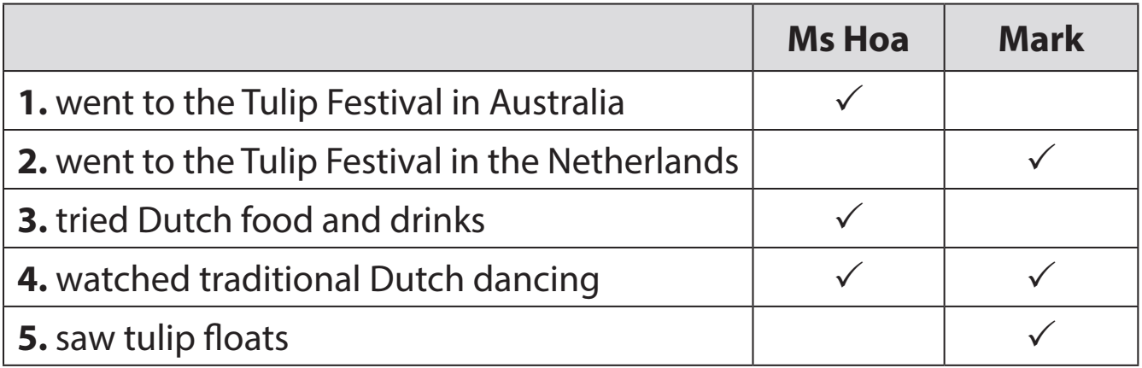 | T-Ss  Ss  Ss-Ss  T-Ss
 | To introduce some more vocabulary related to the topic festivals. | TASK 3: WRITE A WORD OR PHRASE FROM THE BOX UNDER EACH PICTURE. (Ex 3, p. 93)  Game: Who is faster?  * Teacher divides the class into 2 teams. Each team sends a leader to play the game on the board.  - Teacher explains the instructions of the game:  - Teacher gives each team a set of cards with word/phrases from the box.  - The two leaders of the teams come to the board and pin the cards under the correct pictures.  - Who can finish faster with more correct answers will be the winner.  ** Students play the games in team.  *** Teacher has students write down the correct answer.  **** Teacher confirms the answers and gives feedback. Teacher can ask for translation to check their understanding.  Answer key:  1. parade 2. costumes 3. feast  4. float 5. fireworks display 6. folk dance | T-Ss  Team work  T-Ss  T-Ss
 | To help Ss practise the words/ phrases in 3 | TASK 4: FILL IN EACH BLANK WITH A WORD OR PHRASE FROM 3. YOU MAY HAVE TO CHANGE THE FORM OF THE WORD OR PHRASE. (Ex 4, p. 93)  * Teacher asks students to work individually to complete the task. Remind them to change the form of the words/phrases of needed.  ** Students fill in the blanks with the most suitable form of word/ phrase.  *** Teacher allows students to share answers before discussing as a class.  **** Teacher can ask for translation to check their understanding.  Answer key:  1. folk dances 2. fireworks display  3. feast 4. parades  5. floats; costumes | T-Ss  Ss  Ss-Ss  T-Ss
 | To check Ss’ knowledge of some familiar festivals. | Task 5: Quiz. What festival is it? Match each description with a festival (p.93).  * Teacher lets Ss work in groups of 4-6.  ** Ss work in groups to find the answers.  *** Teacher can go around to help weaker students.  **** Teacher calls the first group to come up with the answers to share.  Answer key:  1. e 2. a 3. d 4. c 5. b | T-Ss  Group work  T-Ss  T-Ss
WRAP-UP | To consolidate what students have learnt in the lesson | Teacher asks students to talk about what they have learnt in the lesson. | T-Ss | 3 mins
HOMEWORK | To prepare vocabulary for the next lesson: A closer look 1 | - Name at least 3 festivals around the world.  - Do exercises in the workbook.  - Project preparation  + Teacher informs student of the final project of the Unit’s project  + Explain the requirements of the project: Think of a new festival that you would like to celebrate, then draw pictures or cut out pictures from magazines about that festival. Students will show their work and present in Lesson 7 – Looking back and Project.  + Teacher explains to students how they can get the information.  + Put students into groups and ask them to discuss to assign tasks for each member. Help them set a deadline for each task.  (Teacher should check the progress of students’ preparation after each lesson.) | T-Ss | 2 mins

Date of planning: …. /….. /……...
Date of teaching: …. /….. /……....

Period 70: UNIT 9: FESTIVALS AROUND THE WORLD
Lesson 2: A closer look 1
I. OBJECTIVES
By the end of this lesson, Ss will be able to gain:
1. Knowledge:
- Vocabulary: types of festivals and festival activities
- Pronunciation: pronounce two-syllable words with correct stress
2. Core competence
- Develop communication skills and creativity
- Be collaborative and supportive in pair work and teamwork
- Actively join in class activities
3. Personal qualities
- Develop self-study skills
II. MATERIALS
- Grade 7 textbook, Unit 9, A closer look 1
- Computer connected to the Internet
- Projector/ TV/ pictures
- sachmem.vn
Language analysis
Form | Pronunciation | Meaning | Vietnamese equivalent
1. Cannes Film Festival | /kæn fɪlm festɪvl/ | an annual film festival held in Cannes, France, which previews new films of all genres | Liên hoan phim Cannes
2. Mid-Autumn Festival | /mɪd-ɔːtəm festɪvl/ | he festival which is held on the 15th day of the 8th month of the lunar calendar with a full moon at night | Tết Trung thu
3. Thanksgiving | /ˌθæŋksˈɡɪvɪŋ/ | a national holiday on the fourth Thursday in November in the US and on the second Monday in October in Canada, when families get together for a big meal and express their appreciation for life, health, etc. | Lễ Tạ ơn
4. Easter | /ˈiːstər/ | a Christian religious holiday to celebrate Jesus Christ's return to life after he was killed | Lễ Phục sinh
5. carve | /kɑːv/ | to make something by cutting into especially wood or stone, or to cut into the surface of stone, wood, etc. | chạm, khắc
6. perform | /pəˈfɔːm/ | to do an action or piece of work | biểu diễn
Assumptions
Anticipated difficulties | Solutions
Students may have underdeveloped listening, speaking and co-operating skills. | - Encourage students to work in pairs, in groups so that they can help each other.  - Provide feedback and help if necessary.
Board Plan
Date of teaching
UNIT 9: FESTIVALS AROUND THE WORLD
Lesson 2: A closer look 1

*Warm-up

Game: Hot seat

I. Vocabulary
1. Cannes Film Festival 2. Mid-Autumn Festival
3. Thanksgiving (n) 4. Easter (n)
5. carve (v) 6. perform (v)
II. Practice
Task 1: Write under each picture a festival name.
Task 2: Complete the table below with the phrases.
Task 3: Fill in each blank with a word or phrase.
Task 4: Listen and repeat. Then underline the stressed syllable.
Task 5: Listen and repeat the sentences. Underline the stressed syllables.
* Homework
III. PROCEDURES
Stage | Stage aim | Procedure | Interaction | Time
WARM-UP | - To review the previous lesson and activate students’ knowledge. | GAME: HOT SEAT  * Teacher divides the class into 2 teams. Each team will send a leader to play the game on the board.  - Teacher explains the instructions of the game:  - Each leader stands against the board.  - Teacher shows/ writes the names of the festivals (exercise 5 – page 93).  - Other members from each team describe the festivals and let the leader guess the names of the festivals.  - The team with more correct answers is the winner.  ** Students play in teams.  *** Students give the correct answers.  **** Teacher confirms the answers and gives feedback. | T-Ss  Team work  Ss-Ss  T-Ss | 5 mins
PRESENTATION | To introduce new words. | * Teacher introduces the vocabulary.  ** Teacher introduces the vocabulary by:  - providing the pictures  - providing the definition/ example of the words  1. Cannes Film Festival  2. Mid-Autumn Festival  3. Thanksgiving (n)  4. Easter (n)  5. carve (v)  6. perform (v)  *** Teacher asks students to repeat.  **** Teacher uses the “rub out and check” method to check. | T-Ss  T-Ss  T-Ss | 7 mins
VOCABULARY | To present some types of festivals | TASK 1: WRITE UNDER EACH PICTURE A FESTIVAL NAME FROM THE BOX. (Ex 1, p. 94)  * Teacher has students to look at the pictures and asks them if they know the names of the festivals.  ** Teacher gets students to do the exercise in individuals.  *** Ask them to share their answers in pairs before checking the answers as a class.  **** Teacher then encourages students to explain their answers. Correct if necessary.  Answer key:  1. Halloween  2. Christmas  3. Mid-Autumn Festival  4. Cannes Film Festival  5. Easter  6. Thanksgiving | T-Ss  Ss  Pair work  T-Ss | 25 mins
 | To present some festival activities | TASK 2: COMPLETE THE TABLE BELOW WITH THE PHRASES FROM THE BOX. (Ex 2, p. 94)  * Teacher tells Ss that people celebrate festivals with different food and activities.  ** Teacher asks them to do the task individually.  *** Teacher asks students to share their answers in pairs before checking the answers as a class.  **** Teacher then encourages students to explain their answers. Correct if necessary.  Answer key:  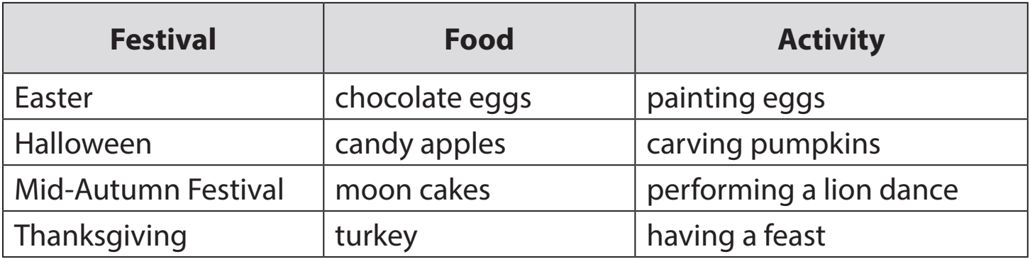 | T-Ss  Ss  Pair work  T-Ss
 | To give Ss further practice with words related to festivals and festivals activities. | TASK 3: FILL IN EACH BLANK WITH A WORD OR PHRASE FROM THE BOX. (Ex 3, p. 94)  * Teacher asks Ss to work in pairs to complete the sentences with the words/ phrases given.  ** Ss work in pairs.  *** Teacher allows students to cross check first.  **** Teacher invites some pairs to share their answers and gives feedback.  Answer key:  1. Christmas 2. painting eggs  3. candy apples  4. Cannes Film Festival  5. Mid-Autumn Festival 6. turkey | T-Ss  Pair work  Ss-Ss  T-Ss
PRONUNCIATION | To help Ss identify how to pronounce two-syllable words with correct stress | TASK 4: LISTEN AND REPEAT. THEN UNDERLINE THE STRESSED SYLLABLE IN EACH WORD. (Ex 4, p. 94)  * Teacher helps Ss to understand what a syllable is. Explain to them that a syllable is a unit of pronunciation having one vowel sound, with or without surrounding consonants, forming the whole part of a word. Give some examples of one-, two- and three-syllable words.  - Tell them that in this lesson, they just focus on two-syllable words and their common stress pattern. Have Ss name some more two-syllable words.  ** Teacher has Ss listen and repeat out the words in the table. Play the recording again for them to underline the stressed syllable in each word.  *** Teacher allows students to cross check first.  **** Teacher lets Ss share their answer and gives feedback. Ask Ss if they recognize any rules related to stress in two-syllable words. Share with them the most common rules.  Answer key:  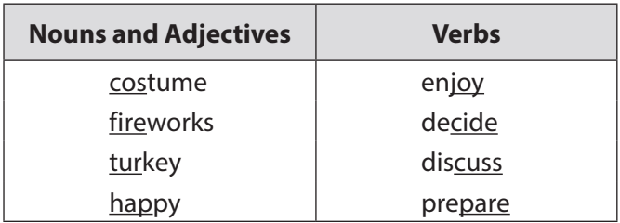 | T-Ss  T-Ss  Ss-Ss  T-Ss
 | To help Ss pronounce two-syllable words with correct stress in sentence. | TASK 5: LISTEN AND REPEAT THE SENTENCES. UNDERLINE THE STRESSED SYLLABLES IN THE BOLD WORDS. (Ex 5, p. 94)  * Teacher has Ss read quickly the sentences and plays the recording. Ask them to pay attention to the bold words and underline the stressed syllables.  ** Students practice in pairs or in groups.  *** Teacher goes around offering help or correcting pronunciation, if necessary.  **** Teacher calls some students to say the sentences in front of the class. Check their pronunciation if necessary. | T-Ss  Group work  T-Ss  T-Ss
PRODUCTION | To test students' quick reaction to the targeted sounds | GAME: UP AND DOWN  *Teacher explains the rules:  Teacher says 1-15 words containing two-syllable words. Students stand up for the ones with first main stress pattern, sit down for the second main stress pattern.  ** Students play the game in teams.  *** Teacher helps students in the game.  **** Teacher gives feedback. | T-Ss  Team work  T-Ss  T-SS | 5 mins
WRAP-UP | To consolidate what students have learnt in the lesson | Teacher asks students to talk about what they have learnt in the lesson. | T-Ss | 2 mins
HOMEWORK | To review the lesson | Do exercises in workbook. | T-Ss | 1 min

